Slack



1. **Website**: [www.slack.com](http://www.slack.com)
2. **Năm thành lập**: Slack was launched in August 2013.In January 2015, Slack announced the acquisition of Screenhero.
3. **Miễn phí/không miễn phí**: Has both free and pricing plans

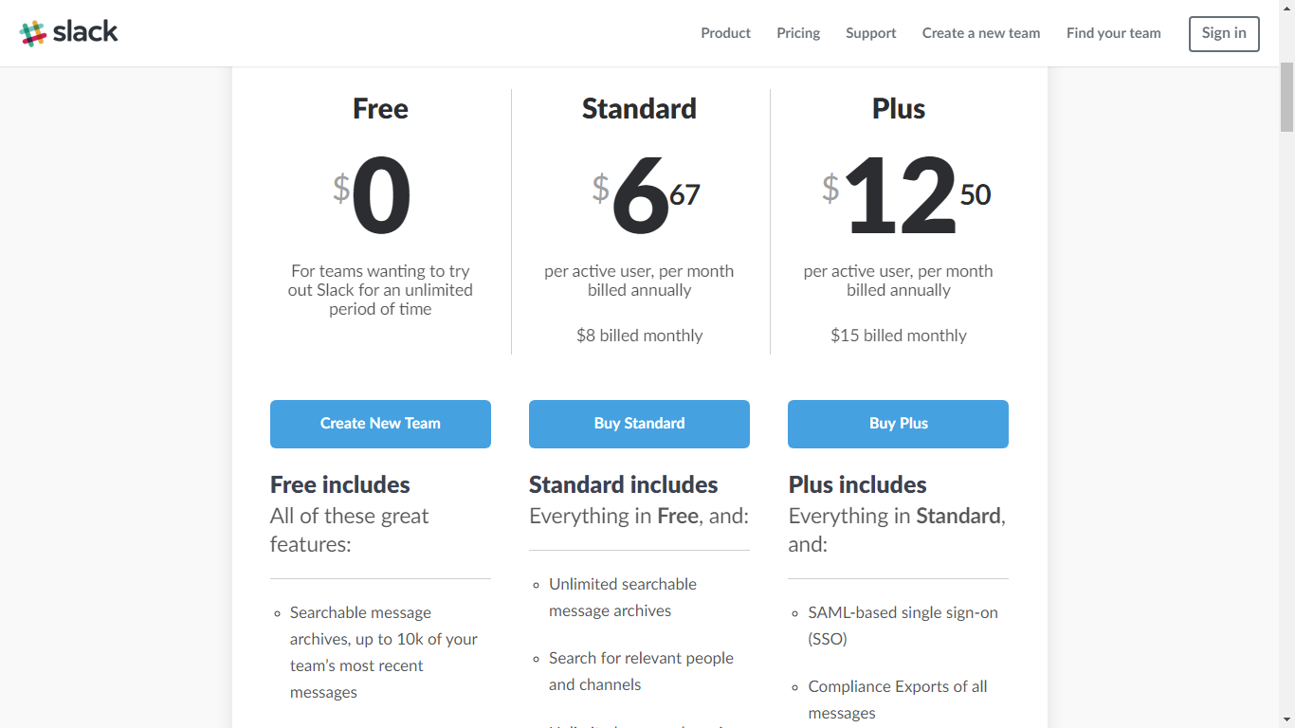

1. **Có app di động không**: Yes (iOS, Android stable release, Window Phone beta App)
2. **Có hỗ trợ các dịch vụ bên thứ 3 không:**

Yes, Slack supports other 3rd parties by letting creating integrated app with Slack:

* Google Drive
* Paypal
* Google Calendar
* Zoho Invoice
* Zoho Expense
* Zoho Book

1. **Các tính năng hỗ trợ:**

* Video chat and message chat
* Team folder.
* Archive searching (everything from files, messages, notifications,…)
* Slack has it own app store, rich and various apps: bot, analytic, HR, marketing

1. **Các khách hàng nổi tiếng sử dụng:**

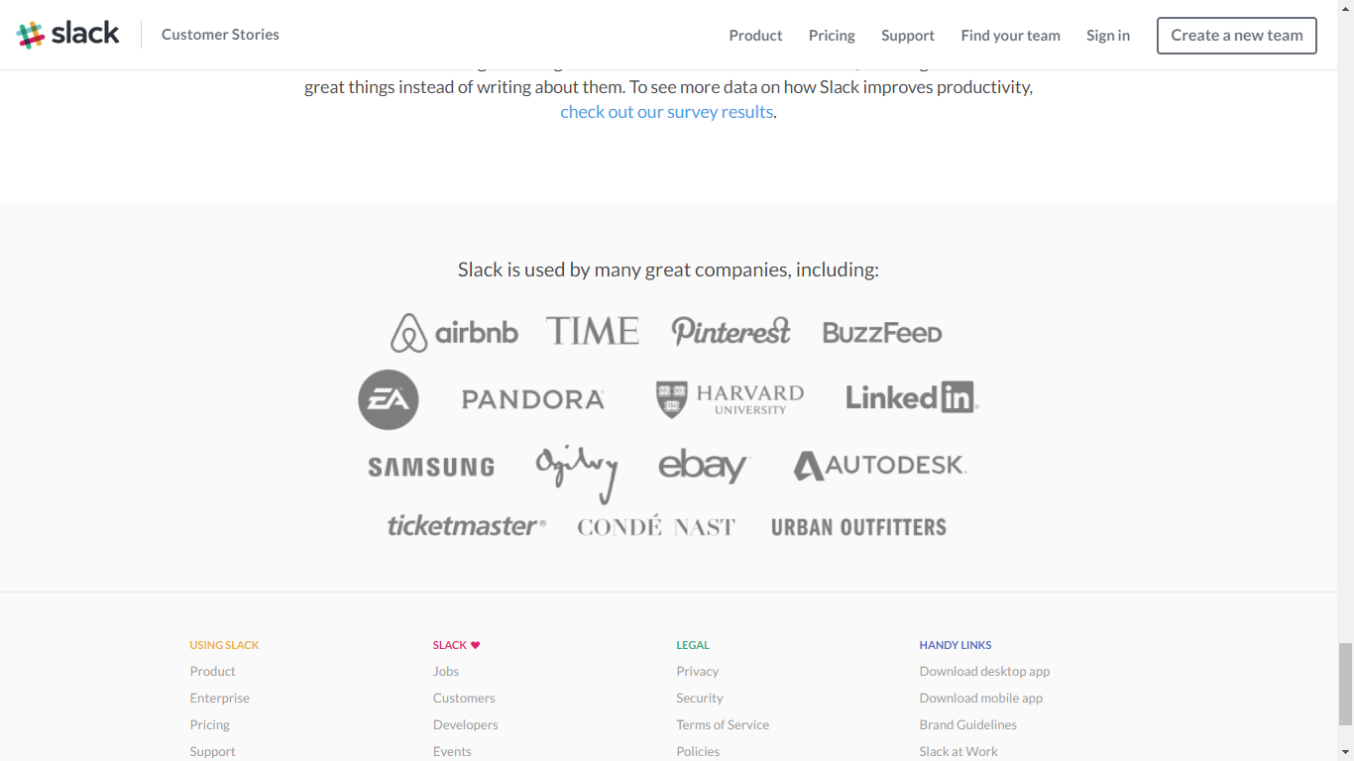

1. **Các giải thưởng (nếu có):**

Slack was recognized as the best startup of the year at the 10th Crunchies Awards, organized by TechCrunch.